KENDRIYA VIDYALAYA
EVS WORKSHEET CLASS : 2
THE SKY AND THE EARTH
Name : -------------------------------------- Roll No.: ------------ Date:
- These are the heavenly bodies. Name them.
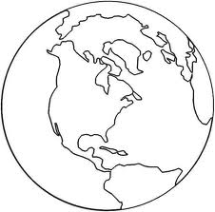
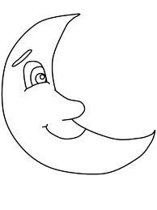
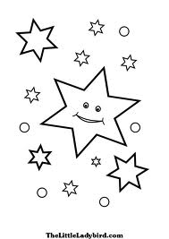
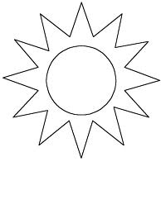

--------------------- --------------------------- ---------------------- -------------------------------
- We can see stars at ----------------------------------------- in the sky.

- The sun sets in the -------------------------------------- .

- When the sun shines it is ------------------------------------ .

- The earth is ----------------------------------- in shape.

- Draw the pictures of :

Night sky | Day sky
- Colour the biggest with orange, smallest with yellow and the other with blue.

- Name the following using the clues.

- Changes the shape. -------------------------------------------------

- Home of all living things. ------------------------------------------------

- Difficult to count the number.----------------------------------------------

- A big ball of fire. -----------------------------------------------

- State true or false.

- The stars are very big. ------------------------------------------

- The moon has light of its own. -------------------------------------

- The sun rises in the west. --------------------------------------------

- The earth is made up of land and water. -----------------------

KENDRIYA VIDYALAYA
EVS WORKSHEET CLASS : 2
SEASONS AND CLOTHES
Name : -------------------------------------- Roll No.: ------------ Date:
- Identify the seasons.
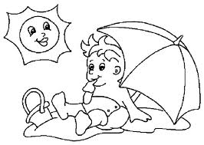
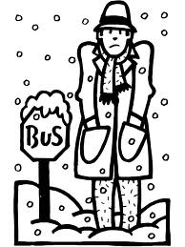

-------------------------------------------------------------- ---------------------------------------------------------
- Name these items. Colour the items we use in summer season with red and item we use in winter with green.
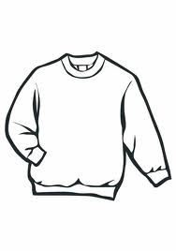
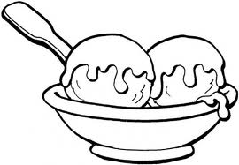

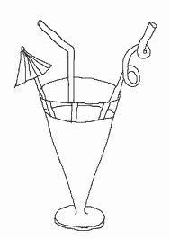

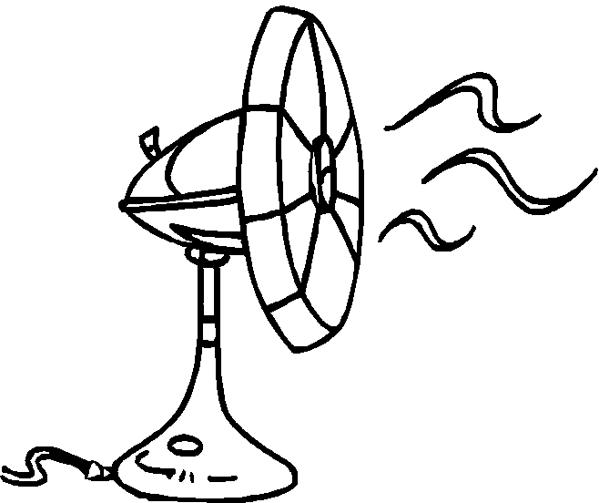
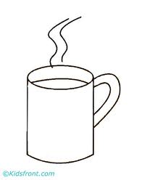

- Fill in the blanks using the words given in the bracket.

[ clothes, seasons, cotton plant, sweat, cotton, woolen, snow]

- -------------------------------- change from time to time.

- In winter there is --------------------------------- on the high mountains.

- ----------------------------- protects us from heat, cold, rain and dust.

- In summer we all -------------------------------- .

- In winter we wear ---------------------------------- clothes.

- In summer we wear ---------------------------------- clothes.

- We get cotton from -----------------------------------.

- State true or false.

- We get wool from horse. ----------------------------

- We take ice cream in winter. ------------------------

- In summer, the sun is very hot. ----------------------------

- We wear same kind of clothes in all seasons. ------------------

