Class I
English Worksheet
Murali’s Mango Tree
Fill in the blanks using the correct word.
- One day Murali ate a ________________________ 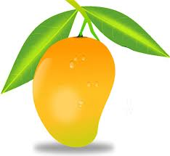

- He threw the __________ behind his house

- Many months later he saw a __________________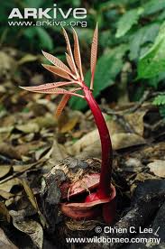
- He watered the ____________________ every day 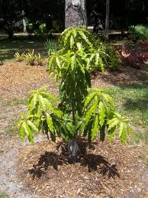

- Many ________________ grew on the tree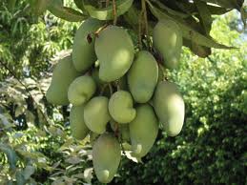
A Little Turtle
- Write the missing letters.
  - t ___ r t l ___
  - sl ___ w
  - h ___ ___ se
  - t ___ i l
  - cr ___ wl

- Colour the turtle and mark its body parts
Shell, head, tail, leg

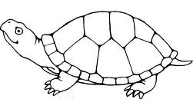

The Tiger and the Mosquito

- Make words from jumbled letters

  - t d r o u ________________
  - t h i ________________
  - g e r t I ________________
  - a p w ________________

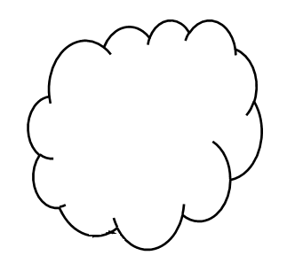
- Fill in the blanks
tiger
mosquito
great

  - A ___________ was dozing under a tree
  - A ___________ came buzzing by
  - Everyone is _______________ in his own way

Our Tree
1. Circle the things that the tree gives us

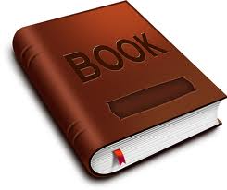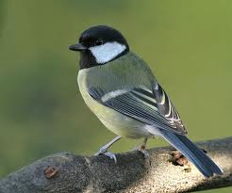

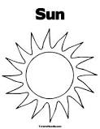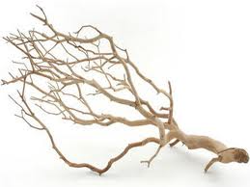
2. Find out rhyming words from the help box and write:
Help box
long, run,
tall, swings

Fall
Sun
Things
Song

Clouds (Poem)
I. Write suitable answers by looking at the picture.
- When it rains, you use an u __ __ __ __ __ __ a 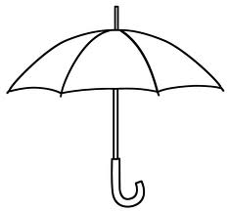

- When it is very hot, you use c __ p

- We sit under a f __ n when it is hot 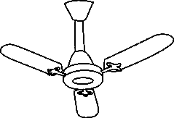
II. Write two words which rhyme with the words given below.
Hot ____________ ________________
Rain ____________ ________________
Cool ____________ ________________
Bring ____________ ________________
III. Match the words with the pictures.
Rain 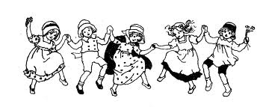

Clouds

Umbrella
Children Dancing 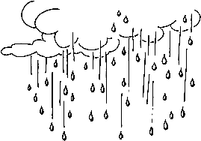

Anandi’s rainbow
I. In the given space draw a rainbow and colour it.

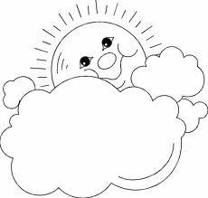

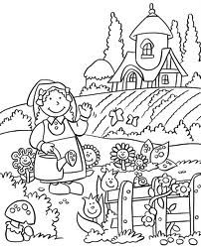
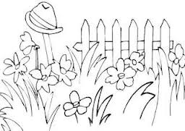

II. Use am / have in the blanks

- I ___________ a good boy
- I ___________ two eyes
- I ___________ a big girl
- I ___________one nose
- I ___________ tall

IF I WERE AN APPLE
I. Match the following
Boy 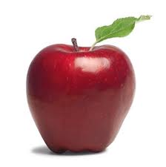
Apple 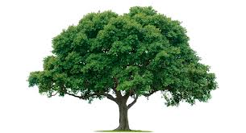
Tree 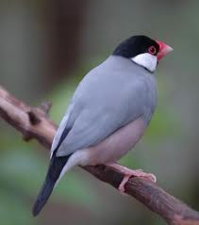
Bird 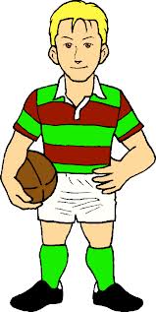

II. Find out the odd one and circle it.

- Apple, Mango, Orange, Table

- Orange tree, Banana, Apple tree, Mango Tree

- Boy, Girl, Grapes, Father

- Dew, Cat, Few, Mew
The Tailor and his Friend
I. Write some of the words which rhyme with the following words.

- Eat -
- Day -
- Wet -
- Shop -

II. Fill in the blanks

- P a __ n
- C h __ l d r e n
- T a __ l o r
- F r __ e n d
- R __ v e r

Which is the letter common in all these words

III. Colour the given picture

