WORKSHEET
CLOTHES
1 ) WE WEAR UMBRELLA AND RAINCOATS IN RAINY SEASON
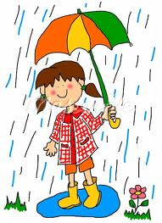
COLOUR THE PICTURE.
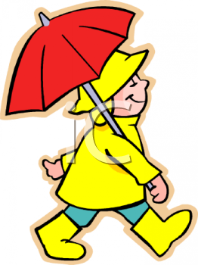
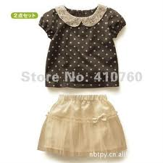
2 ENCIRCLE THE CLOTHES WEAR IN WINTER SEASON
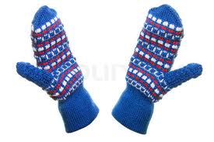
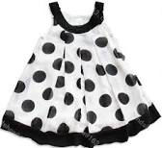
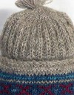

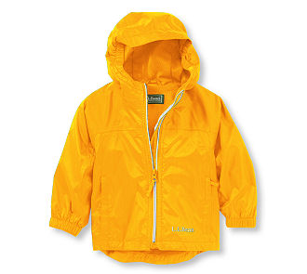
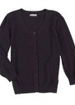

111 Match the following

