CLASS - I
EVS WORKSHEET
I. Identify the means of transports and name these
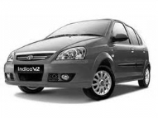
……………………………….

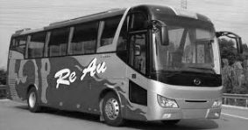
……………………….

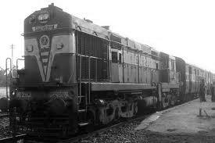

……………………………………….
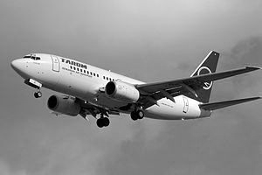

…………………………………………….

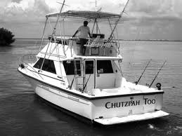

…………………………………..

II. Draw and colour your favourite vehicle

III. Encircle names of vehicles which move on land.

Car Aero plane Bus Jeep Ship

Lorry Cycle Bullock Cart Boat

