Match the following
A person who sails the ship an artist
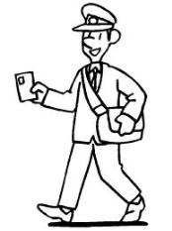
A person who paints a postman
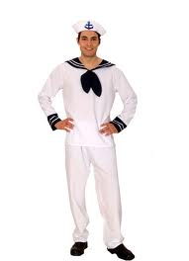
A person who brings letters a sailor

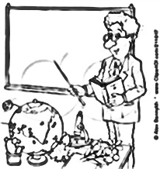
A person who stitches clothes teacher
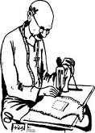
A person who works in school tailor
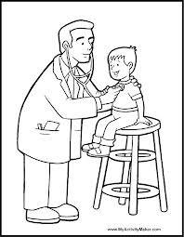
A person who flies an aeroplane doctor

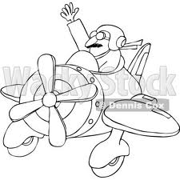
A person who flies a spaceship pilot
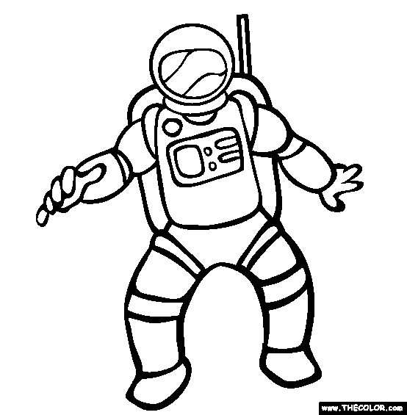

A person who treats sick people astronaut

